Standard | Items:
K.RF.02 - Demonstrate understanding of spoken words, syllables, and sounds (phonemes). T3  b) Count, pronounce, blend, and segment syllables in spoken words.  c) Blend and segment onsets and rimes of single-syllable spoken words.  d) Isolate and pronounce the initial, medial vowel, and final sounds (phonemes) in three-phoneme (consonant-vowel-consonant, or CVC) words. (This does not include CVCs ending with /l/, /r/, or /x/.)  f) Blend two to three phonemes into recognizable words. CA | 3.0  - b) Count, pronounce, blend, & segment syllables in spoken words.  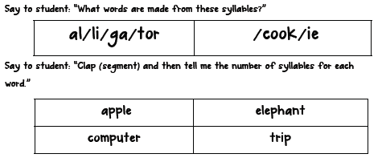  - c) Blend & segment onsets & rimes of single-syllable spoken words.  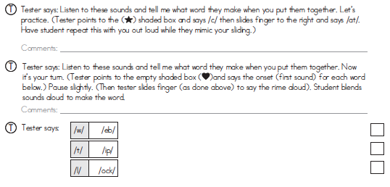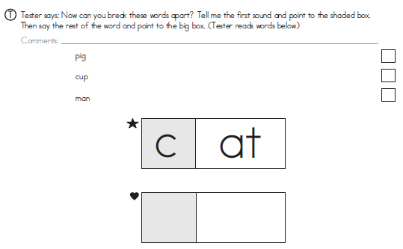  - d) Isolate and pronounce the initial sounds (phonemes) in three-phoneme (consonant-vowel-consonant, or CVC) words. (This does not include CVCs ending with /l/, /r/, or /x/.)  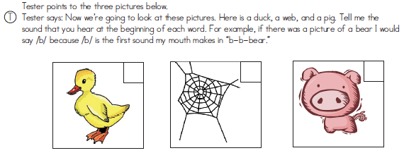  - d) Final/ending sounds  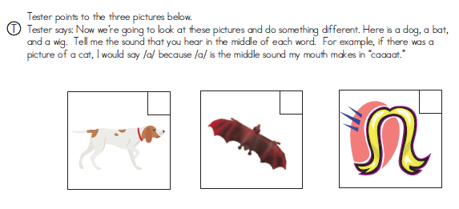  - d) Medial vowel sounds  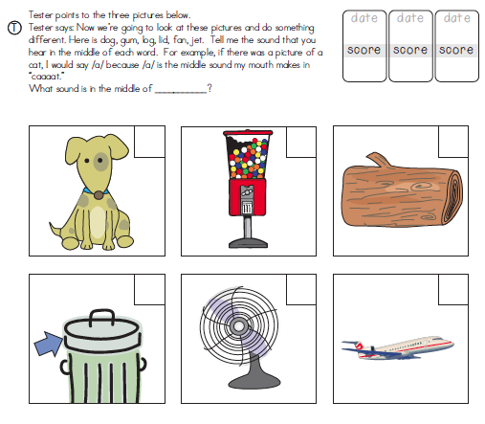  6. e) Add or substitute individual sounds (phonemes) in simple, one-syllable words to make new words.  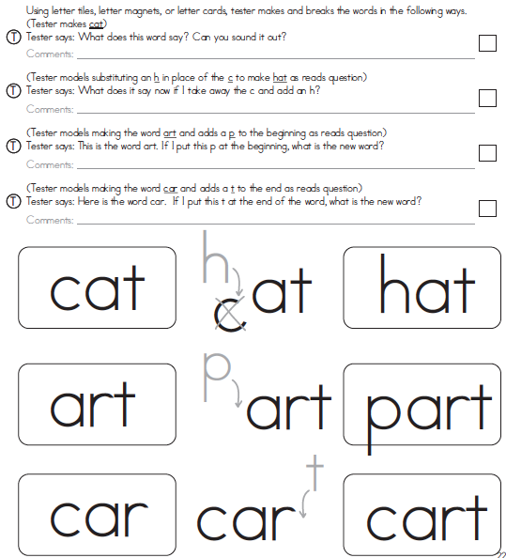  7. f) Blend two to three phonemes into recognizable words. CA  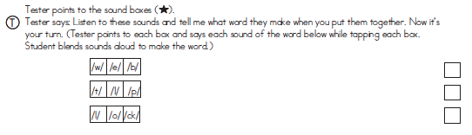
 | 2.0
K.RF.03 -  Know and apply grade-level phonics and word analysis skills in decoding words.T3  c) Read common high-frequency words by sight (e.g., the, of, to, you, she, my, is, are, do, does).  d) Distinguish between similarly spelled words by identifying the sounds of the letters that differ. | 3.0  - c) Read common high-frequency words by sight (e.g., the, of, to, you, she, my, is, are, do, does).  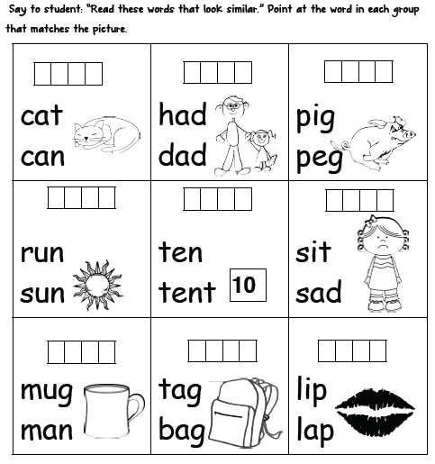
 | 2.0
K.RI.1 -  With prompting and support, ask and answer questions about key details in a text. T3 | 3.0  - Tell me what happens at the beginning of this story.  - What happens next (middle of the story).  - What happens at the end of the story?  - Who are the characters in the story?  - Where does the story take place? What is the setting?  - What is the problem of the story?  - What is the job of the author?  - What is the job of the illustrator?
 | 2.0
K.W.01 -  Use a combination of drawing, dictating, and writing to compose opinion pieces in which they tell a reader the topic or the name of the book they are writing about and state an opinion or preference about the topic or book (e.g., My favorite book is . . .). T3 | 3.0  - 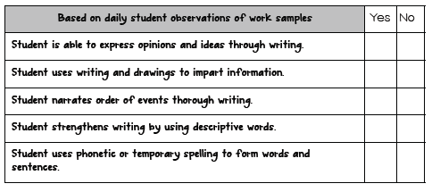  - 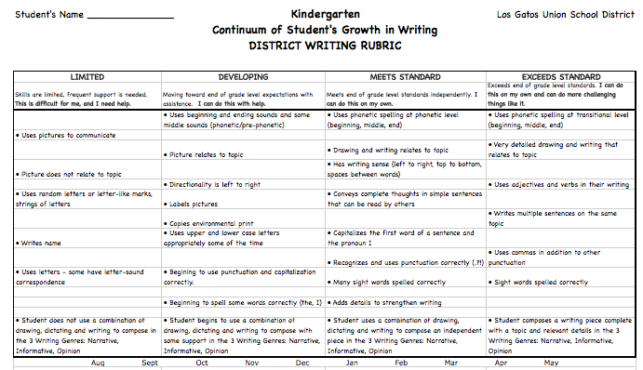
2.0
- May need other assessment tool for writing standard.

K.L.01-  Demonstrate command of the conventions of standard English grammar and usage when writing or speaking. T2/3  a) Print many upper- and lowercase letters. | 3.0  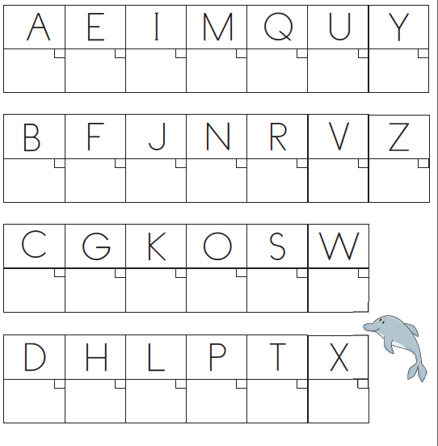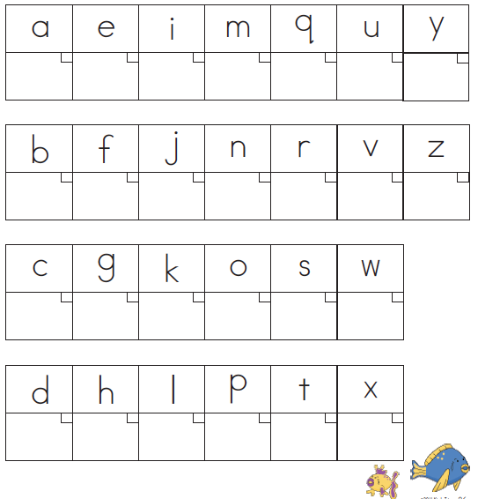
 | 2.0
K.L.01-  Demonstrate command of the conventions of standard English grammar and usage when writing or speaking. T2/3  b) Use frequently occurring nouns and verbs.  c) Form regular plural nouns orally by adding /s/ or /es/ (e.g., dog, dogs; wish, wishes).  d) Understand and use question words (interrogatives) (e.g., who, what, where, when, why, how).  e) Use the most frequently occurring prepositions (e.g., to, from, in, out, on, off, for, of, by, with).  f) Produce and expand complete sentences in shared language activities. | 3.0  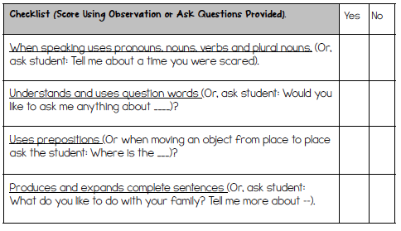
 | 2.0
K.L.02 -  Demonstrate command of the conventions of standard English capitalization, punctuation, and spelling when writing. T3  a) Capitalize the first word in a sentence and the pronoun I.  b) Recognize and name end punctuation.  c) Write a letter or letters for most consonant and short-vowel sounds (phonemes).  d) Spell simple words phonetically, drawing on knowledge of sound-letter relationships. | 3.0
 | 2.0

